TRINITY INNOVATIONS
Injection Rate Adjustment Instructions
EFC-CPU

(780)672-2775

Step 1: Energize CPU Version numbers should appear
(Your version may be different from the picture below)

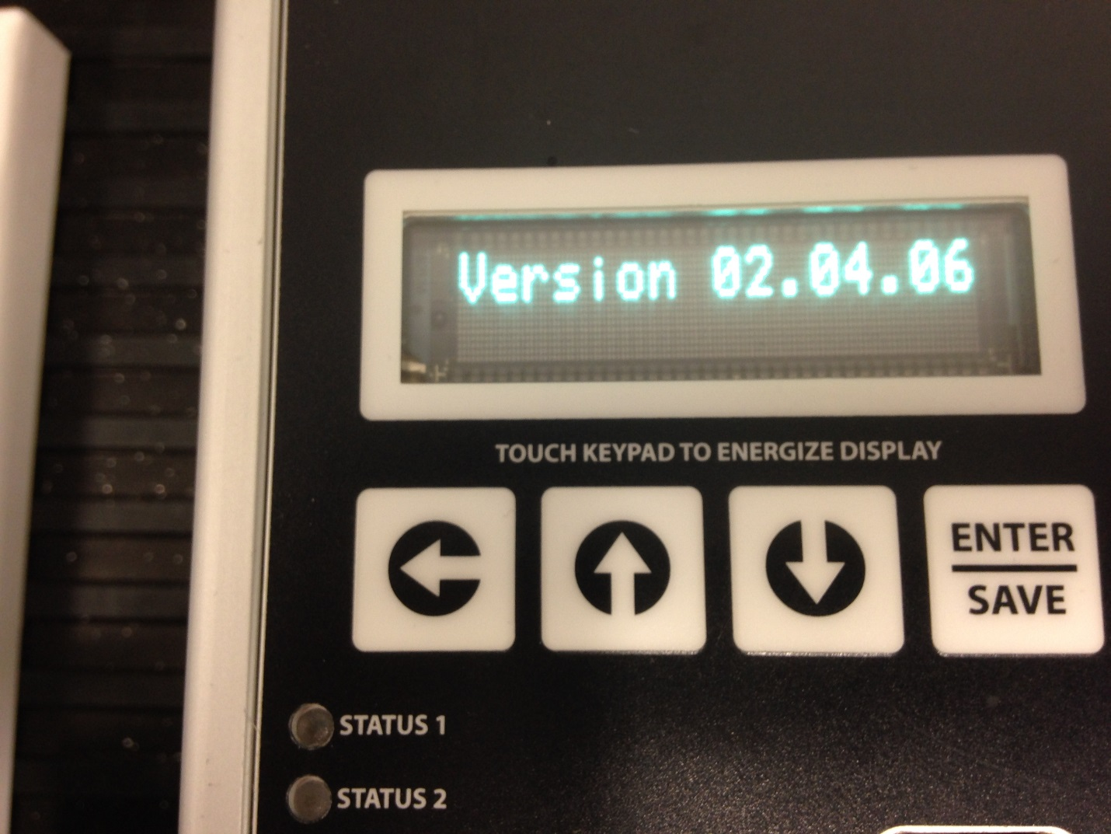

Step 2: Press Down Arrow Key- Inject Rate 1 should appear

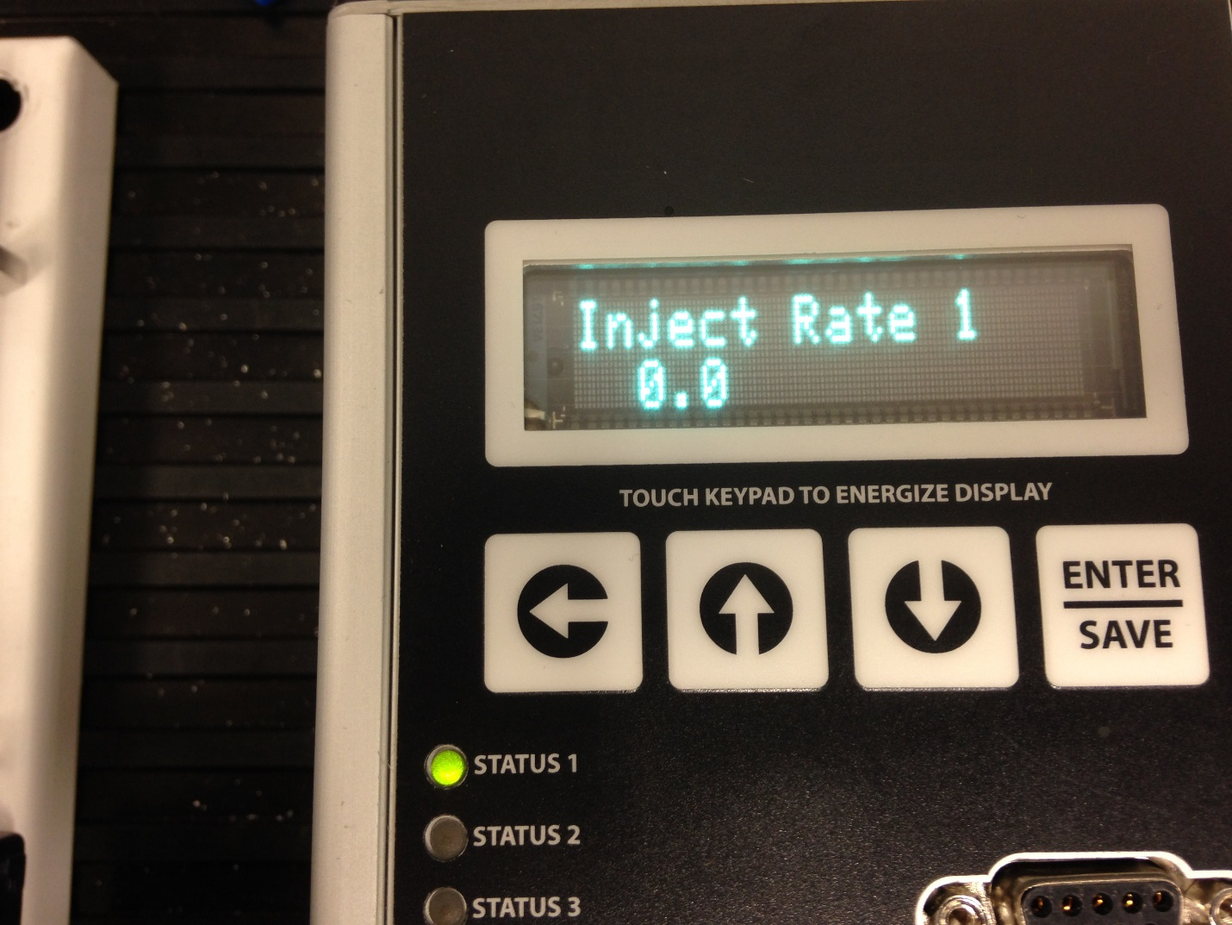

Step 3: Press Enter, Cursor should be flashing

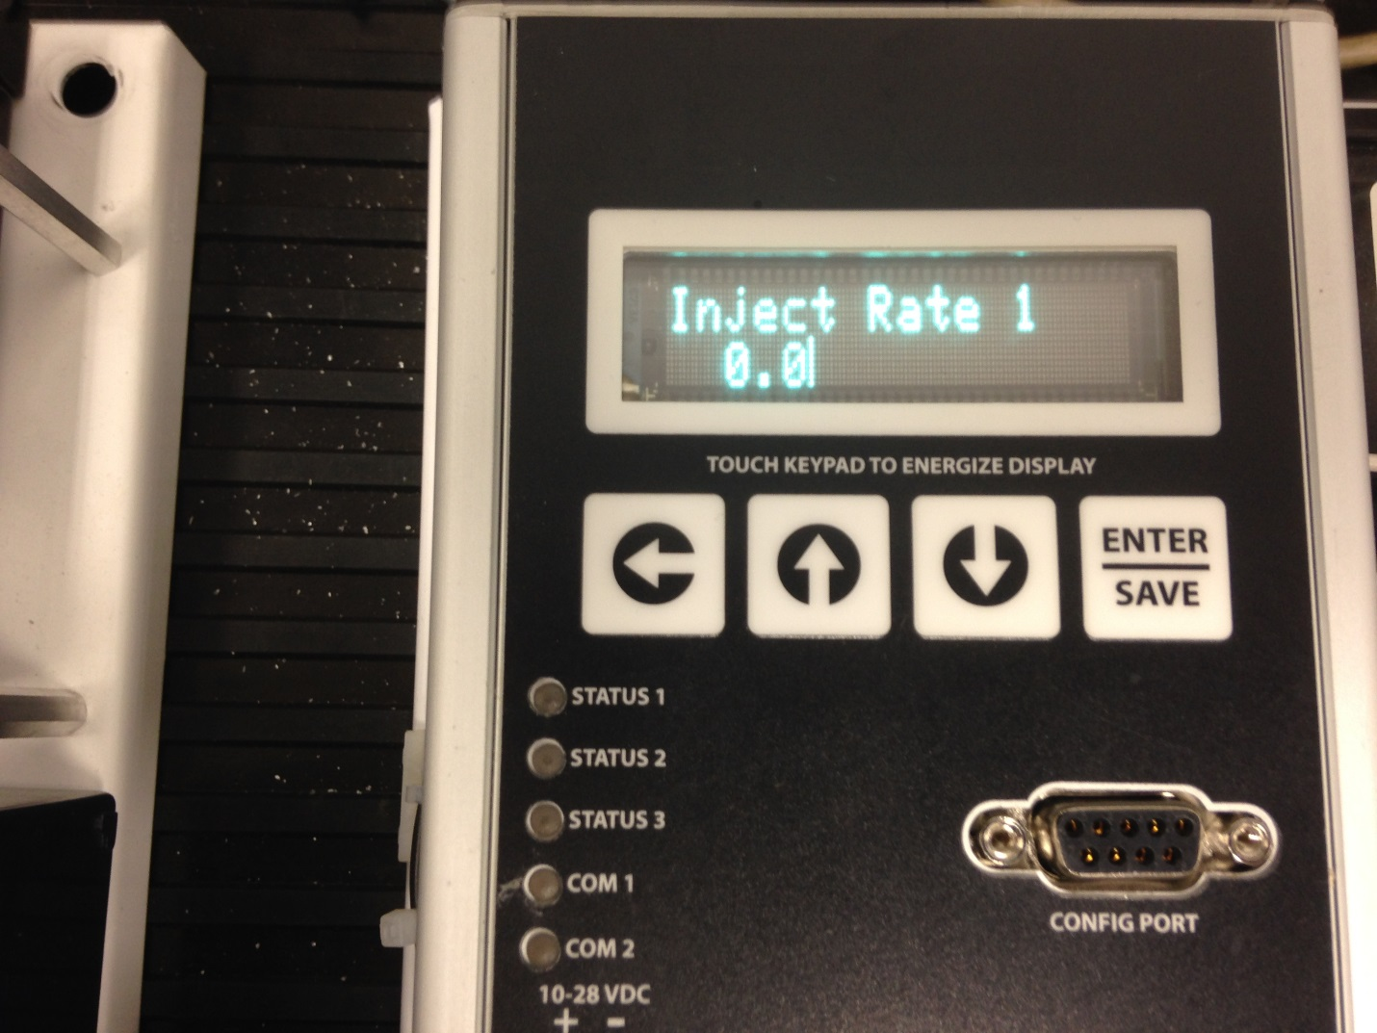

Step 4: Use Left Arrow to Move Cursor Over

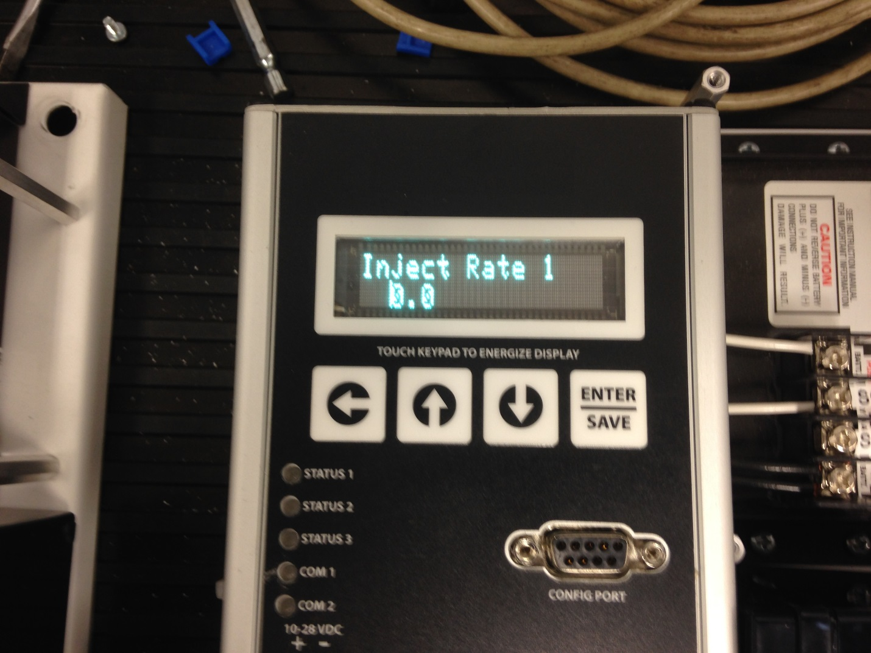

Step 5: Then Use Up & Down Arrow Keys To Set Liters per Day

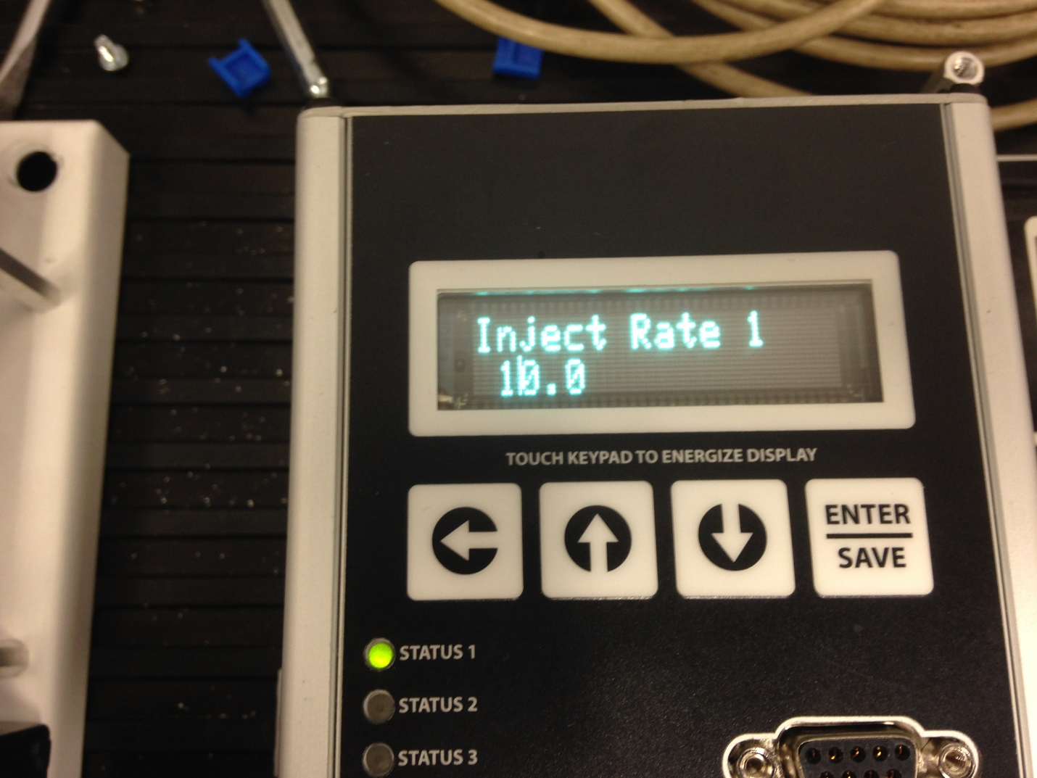

Step 6: Press Enter/Save To Save The Injection Rate

