EMERALD BOILER AND PRESSURE VESSEL INSPECTIONS INC.

BOX 75 STATION MAIN

WHITE CITY, SASKATCHEWAN

S4L 5B1

July 18, 2013

Repair Procedure

Natco 6’ x 27’ Emulsion Treater

Lightstream 05-05-11-07 W2M Battery

Scope of work:

Lacewelding pitted areas in water section shell, bottom head and gas section manway lip.

Lightstream 05-05-11-07 W2M Battery

Size: 6’x 27’ Treater

S/N: L-6-251

CRN: D781.21

MAWP: 50 PSI @ 200 F

MFG: Natco

A TSASK TSK-0001Installation or Repair/Alteration Permit will be completed and submitted to TSASK along with the applicable fee by Supreme/Flint Energy shop in Estevan. Supreme/Flint Energy Estevan shop to confirm with TSASK on the approval of this repair. Treater to notify TSASK’s regional inspector before weld repairs commence.

Treater requires a hydrogen bake-out completed on all lace weld areas prior to welding. Treater is in a sour service state. All areas will be baked at 550F for one hour prior to welding commencing.

A Lightstream, Supreme/Flint safe work permit shall be completed and approved before repair starts.

Internal area on this treater shall have safe atmosphere before weld repair commences.

Areas requiring lacewelding will be prepped by a qualified Supreme/Flint welder.

A new sealed box of the applicable 7018 welding rod sizes shall be opened and placed in a calibrated, heated rod storage oven. Temperature shall be maintained as per recommend by the welding rod manufacturer.

Repair areas after the hydrogen backed out areas shall have a preheat conducted as per Supreme/Flint’s weld procedure.

All parameters for this repair shall be followed throughout the entire weld repair process, unless otherwise specified. Welding shall commence immediately after the preheat temperature has been achieved. Careful attention to the shell temperature will be required as this is a small welding temperature window. Temperature on preheat and during the welding process shall be monitored with the applicable temperature range crayons or a certified infrared temperature gun.

Excavated area shall be welded out with a finished surface that match’s original shell thickness using 1/8” 7018 welding rod. Once welding has been completed the weld repaired area will be covered with an insulating blanket to control the cool down rate.

A 12 hour visual, B&W MPI inspection will be completed after welding has been completed. If no indication are present the treater will be sandblasted and recoated throughout all sections.

A hydro test will not be completed as no pressure boundary has been broken.

Supreme/Flint Energy QC turnover package shall be reviewed and complete with sign off’s from the assigned visual inspector.

QC package shall forward to Lightstream for review and acceptance.

___________________________________________________________________________________

Cory Sasyniuk Neil Pinkney

Phone: (306) 527-2025 (cell) Phone: (306) 527-2024 (cell)

Phone: (306) 781-3067 (home) Phone: (306) 781-5673 (home)

E-mail: [emerald.cory@sasktel.net](mailto:emerald.cory@sasktel.net) E-mail: [emerald.neil@sasktel.net](mailto:emerald.neil@sasktel.net)

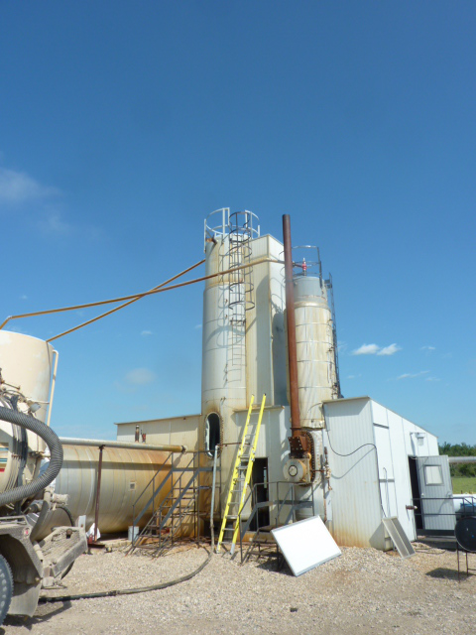

A0191798 Vertical Natco Treater at 05-05-011-07W2M

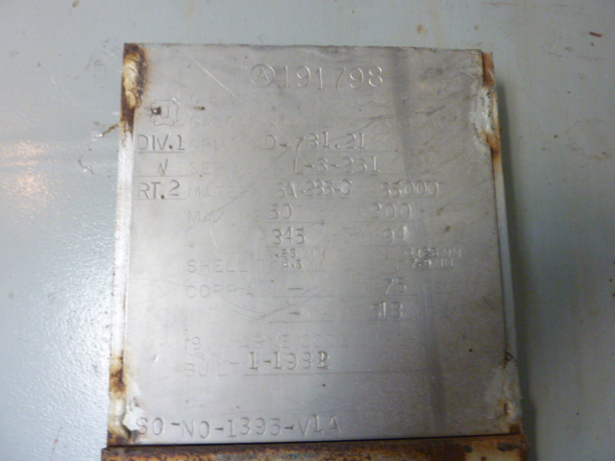

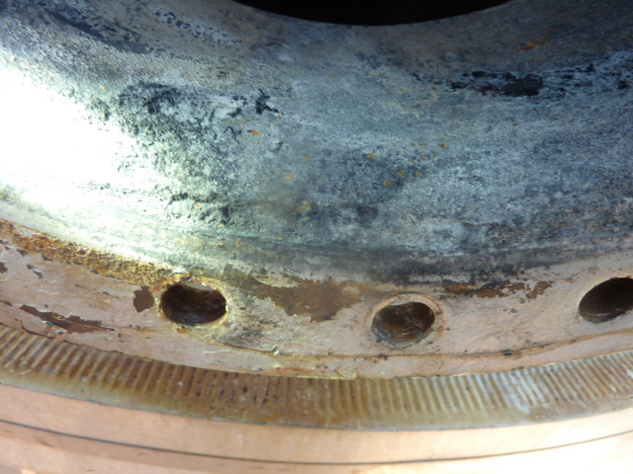

Manway lip corrosion (gas section)

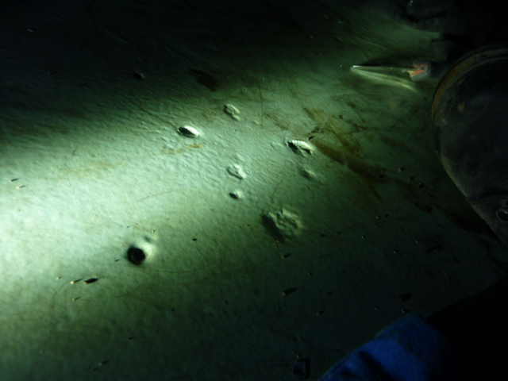

Bottom head pitting

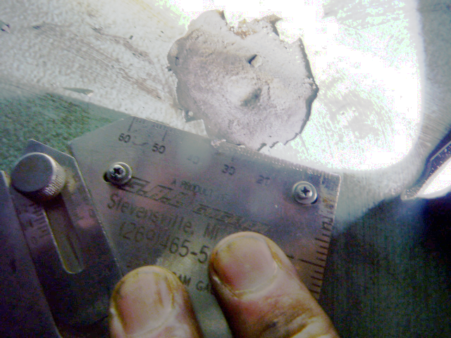

Bottom head pitting

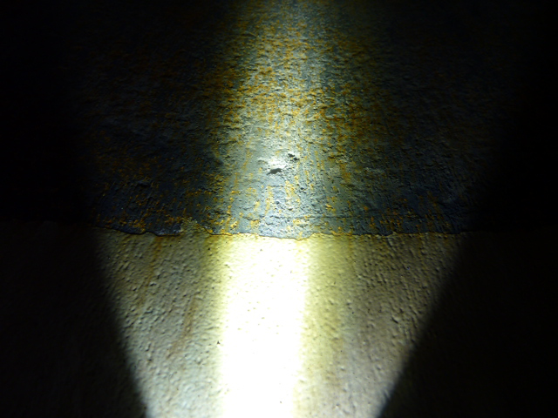

Oil section Shell Pitting